An example of a submission title: an essay for submissions to the Brazilian Journal of the Environment

Jadson Freire da Silva[](https://www.researchgate.net/profile/Jadson_Silva)1*, Elisabeth Regina Alves Cavalcanti Silva[](http://lattes.cnpq.br/3591530170527406)2, Afonso Feitosa Reis Neto[](http://lattes.cnpq.br/7382862676934597)3, Rutt Keles Alexandre da Silva[](https://orcid.org/0000-0001-8062-0055)4, Josimar Vieira do Reis[](https://orcid.org/0000-0002-4466-1244)5

1*PhD in Development and Environment, Centro Universitário Brasileiro, Brazil. (\**Corresponding author*:* jadsonfreireufpe@hotmail.com)

*2PhD in Development and Environment, Instituto Federal do Maranhão, Brazil.*

*3PhD in Development and Environment, Instituto Federal do Piauí, Brazil.*

*4PhD in Development and Environment, Universidade Federal do Ceará, Brazil.*

*5PhD in Development and Environment, Universidade Federal de Pernambuco, Brazil.*

**A B S T R A C T**

Attention, please read the instructions carefully: The abstract should contain a brief introduction, and the objectives should be presented at the end. Subsequently, briefly describe the materials and methods used. Present the equipment and methodologies employed, citing sources when necessary. Present the results clearly and objectively. The results should be presented and discussed. Conclude the work in a clear and concise manner. There must be an abstract (Portuguese), an abstract in English, and an abstract (Spanish). The maximum number of words allowed in the abstracts is 250. Keywords will be allowed, with a maximum of 5 and a minimum of 3; these keywords will be used for indexing purposes. The font for the abstract is Times New Roman, size 9. A concise and factual abstract is necessary. The abstract should briefly indicate the research objective, the main results, and the main conclusions. References or citations within the abstract should be avoided, but if exceptionally necessary, cite the author(s) and year(s). Additionally, non-standard or uncommon abbreviations should be avoided, but if essential, they must be defined in their first mention in the abstract itself.

**Keywords:** Example, Example, Example.

Title in Portuguese (Times New Roman 13)

**R E S U M O (PT-BR)**

Atenção, leia atentamente as instruções: O resumo deve conter uma breve introdução, e os objetivos devem ser apresentados ao final. Posteriormente, descreva brevemente os materiais e métodos utilizados. Apresentar os equipamentos utilizados e as metodologias empregadas, citando as fontes quando necessário. Apresente os resultados de forma clara e objetiva. Os resultados devem ser apresentados e discutidos. Conclua o trabalho de forma clara e concisa. Deve haver um resumo (português), um resumo em inglês (abstract) e um resumo (espanhol). O número máximo de palavras permitido nos resumos é de 250. Palavras-chave serão permitidas no máximo 05 palavras-chave e no mínimo 03, essas palavras-chave serão usadas para fins de indexação. A fonte do resumo é Times New Roman tamanho 9. É necessário um resumo conciso e factual. O resumo deve indicar brevemente o objetivo da pesquisa, os principais resultados e as principais conclusões. As referências ou citações dentro do resumo devem ser evitadas, mas se necessário de modo excepcional, cite o(s) autor(es) e o(s) ano(s). Além disso, abreviações fora do padrão ou incomuns devem ser evitadas, mas, se essenciais, devem ser definidas em sua primeira menção no próprio resumo.

**Palavras-Chaves**: Exemplo, Exemplo, Exemplo.

Title in Spanish (Times New Roman 13)

**R E S U M E N (SPANISH)**

Atención, por favor lea las instrucciones detenidamente: El resumen debe contener una breve introducción y los objetivos deben presentarse al final. Después, describa brevemente los materiales y métodos utilizados. Presente los equipos utilizados y las metodologías empleadas, citando fuentes cuando sea necesario. Presente los resultados de forma clara y objetiva. Los resultados deben ser presentados y discutidos. Concluya el trabajo de forma clara y concisa. Debe haber un resumen (portugués), un resumen en inglés (abstract) y un resumen en español. El número máximo de palabras permitido en los resúmenes es de 250. Se permitirán un máximo de 5 palabras clave y un mínimo de 3, estas palabras clave serán utilizadas para fines de indexación. La fuente del resumen es Times New Roman, tamaño 9. Es necesario un resumen conciso y factual. El resumen debe indicar brevemente el objetivo de la investigación, los principales resultados y las principales conclusiones. Se deben evitar las referencias o citas dentro del resumen, pero si es necesario excepcionalmente, cite al autor o autores y el año. Además, se deben evitar abreviaciones fuera del estándar o inusuales, pero si son esenciales, deben ser definidas en su primera mención en el propio resumen.

**Palabras clave**: Ejemplo, Ejemplo, Ejemplo.

1. **Graphical Abstract** **(OPTIONAL)**

The Graphical Abstract or also known as Visual Abstract is a single, concise, pictorial, and visual summary of the main findings of the article. It can be the final/starting figure of the article or, even better, a specially designed figure that captures the content of the article for readers at a single glance and can be in other environments besides the article itself. Below is an example of how to create a graphic summary. It is just an example:

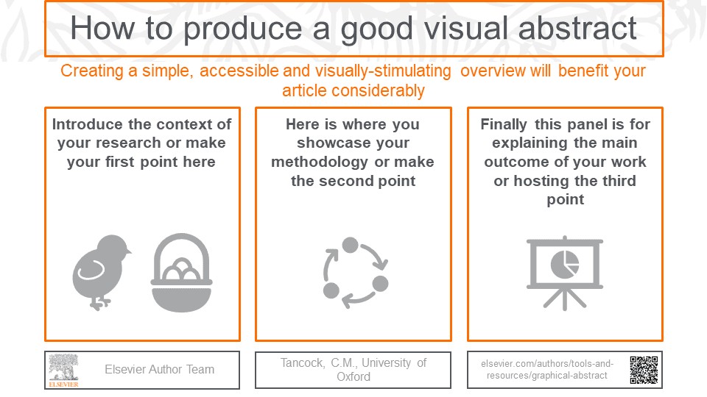

The author can create his or her Graphic Summary in any way he or she wants and with the elements and models he or she wants, if they respect the size and proportionality of the image, as well as that the elements are visible and not polluted:

[**https://www.elsevier.com/authors/tools-and-resources/graphical-abstract**](https://www.elsevier.com/authors/tools-and-resources/graphical-abstract)

**<https://www.revistabrasileirademeioambiente.com/index.php/RVBMA/announcement/view/77>**

We emphasize that the Graphical Abstract is optional for each researcher, being optional to create and submit it in the cover letter. If the author is not interested in making a Graphical Abstract, he/she is free to leave this part blank or not modify it.

1. **Cover Letter (Article)**

Briefly present the importance of your article and its relation to the journal.

1. **Concordance (Rules)**

The authors declare that:

a) This work is original and has not been published or submitted, in whole or in part, to any other journal or scientific publication, regardless of the language. If the article is part of a Final Course Paper, Dissertation, or Thesis, it has been previously notified in the "comments to the editor" section.

b) All authors listed in this work agree and are aware of their inclusion as authors.

c) They have read and followed the author guidelines provided in the "About" section correctly. Failure to comply with these guidelines may result in the article being disqualified and rejected.

d) If the article is accepted, the authors agree to grant the journal the right to digitally reproduce the work titled above (or the title subsequently adopted to meet the suggestions of reviewers and editors).

e) Conflicts of interest have been properly indicated within the body of the work.

f) All authors have made substantial contributions to this work, including the conception of the research project, analysis and interpretation of the data, writing, and critical review, certifying that they have participated sufficiently in the work to publicly assume responsibility for its content.

g) They have obtained permission from all individuals mentioned in the Acknowledgments and photos.

h) They have observed the publication guidelines and article template available on the website of the journal.

i) that have not used artificial intelligence software for textual development in the document.

By submitting this document along with the article, the corresponding author guarantees the **truthfulness of all the aspects mentioned above**. **Failure to comply may result in possible legal action**. Any subsequent questions or disputes regarding the inclusion or exclusion of authors in the research, permission, or non-permission of authors in the research, or other details may lead to **the suspension or rejection of the research, even if published, accompanied by a letter of retraction**.

1. **References**

*How would the reference for your article be in the format below (APA):*

Surname, A., Surname, B., Surname, C., Surname, D. (20XX). Example of Title: Example of Title. **Brazilian Journal of Environment**.

Surname, A., Surname, B., Surname, C., Surname, D. (20XX). Example of Title: Example of Title. **Brazilian Journal of Environment**.

**5. Contributions of each author in the research.**

For the contributions of each author in the research, the functions of: Conceptualization; Data curation; Formal analysis; Fundraising; Investigation; Methodology; Project management; Resources; Programs; Oversight; Validation; Visualization; Papers/Writing - original draft; and Writing - review and editing. Please note that not all roles may apply to all manuscripts, and authors may have contributed through multiple roles.

Therefore, list below each author's name and what they performed on the article.

Author name 1: Contribution:

Author name 2: Contribution:

Author name 3: Contribution:

Author name 4: Contribution:

Author name 5: Contribution:

1. **Orcid – ReseachGate or Lattes link (OPTIONAL)**

Author Name 1: Preferred Link:

Author Name 2: Preferred Link:

Author Name 3: Preferred Link:

  